Control Lesson 4

[1. Sebastian Introduction](https://classroom.udacity.com/nanodegrees/nd787/parts/3619d672-ce5b-4a29-8a15-172cb667b5bb/modules/b78ec22c-5afe-444b-8719-b390bd2b2988/lessons/2263120a-a3c4-4b5a-9a96-ac3e1dbae179/concepts/3073a92d-2364-43e6-af58-048622948f2e)

<https://www.youtube.com/watch?time_continue=32&v=DH70DtWEOW0>

[2. Lesson Overview](https://classroom.udacity.com/nanodegrees/nd787/parts/3619d672-ce5b-4a29-8a15-172cb667b5bb/modules/b78ec22c-5afe-444b-8719-b390bd2b2988/lessons/2263120a-a3c4-4b5a-9a96-ac3e1dbae179/concepts/0cb7274f-7718-4be8-9739-86d0054ad77e)

<https://www.youtube.com/watch?time_continue=77&v=TkbKNvu67bo>

[3. Review of 2D Dynamics](https://classroom.udacity.com/nanodegrees/nd787/parts/3619d672-ce5b-4a29-8a15-172cb667b5bb/modules/b78ec22c-5afe-444b-8719-b390bd2b2988/lessons/2263120a-a3c4-4b5a-9a96-ac3e1dbae179/concepts/9ec0a348-f839-4ca3-aab3-04f9b13709e3)

<https://www.youtube.com/watch?v=AhdEPjfhFWc>

**import** numpy **as** np  
**import** math  
  
**class** **Drone2D**:  
  
  
 **def** **__init__**(self,  
 I_x = 0.1, # moment of inertia around the x-axis  
 m = 0.2, # mass of the vehicle   
 ):  
  
 self.I_x = I_x  
 self.m = m  
  
 self.u1 = 0.0  
 self.u2 = 0.0  
 self.g = 9.81  
  
 self.X = np.array([0.0,0.0,0.0,0.0,0.0,0.0])  
  
 *# the following 3 functions are used by advance_state*  
 *# to get the accelerations of the vehicle.*  
 @property  
 **def** **y_dot_dot**(self):  
 phi = self.X[2]  
 **return** self.u1 / self.m * np.sin(phi)  
  
 @property  
 **def** **z_dot_dot**(self):  
 phi = self.X[2]  
 **return** self.g - self.u1*math.cos(phi)/self.m  
  
 @property  
 **def** **phi_dot_dot**(self):  
 **return** self.u2 / self.I_x  
  
 **def** **advance_state**(self, dt):  
  
 X_dot = np.array([self.X[3],   
 self.X[4],  
 self.X[5],   
 self.z_dot_dot,  
 self.y_dot_dot,   
 self.phi_dot_dot])  
  
  
 *# Change in state will be*   
 self.X = self.X + X_dot * dt  
 **return** self.X   
  
 **def** **set_controls**(self, u1, u2):  
 self.u1 = u1  
 self.u2 = u2

[4. World vs Body Frames](https://classroom.udacity.com/nanodegrees/nd787/parts/3619d672-ce5b-4a29-8a15-172cb667b5bb/modules/b78ec22c-5afe-444b-8719-b390bd2b2988/lessons/2263120a-a3c4-4b5a-9a96-ac3e1dbae179/concepts/87783576-e018-4d22-88eb-c2d6bc1988ef)

<https://www.youtube.com/watch?v=zFhip1JLgAY>

[5. Tracking 3D Dynamics Overview](https://classroom.udacity.com/nanodegrees/nd787/parts/3619d672-ce5b-4a29-8a15-172cb667b5bb/modules/b78ec22c-5afe-444b-8719-b390bd2b2988/lessons/2263120a-a3c4-4b5a-9a96-ac3e1dbae179/concepts/e9f5ed3f-d0b1-4d6a-b5a6-fd751f3c9149)

<https://www.youtube.com/watch?v=QxShTrK2vus>

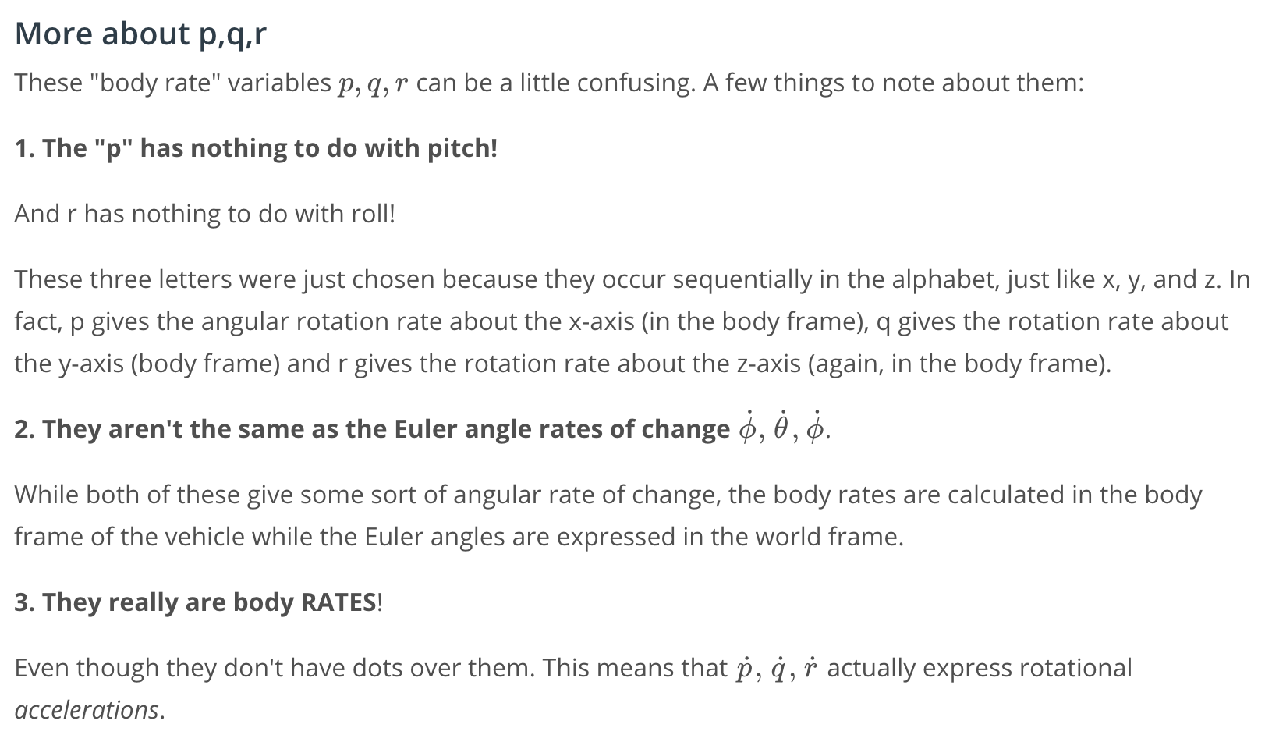

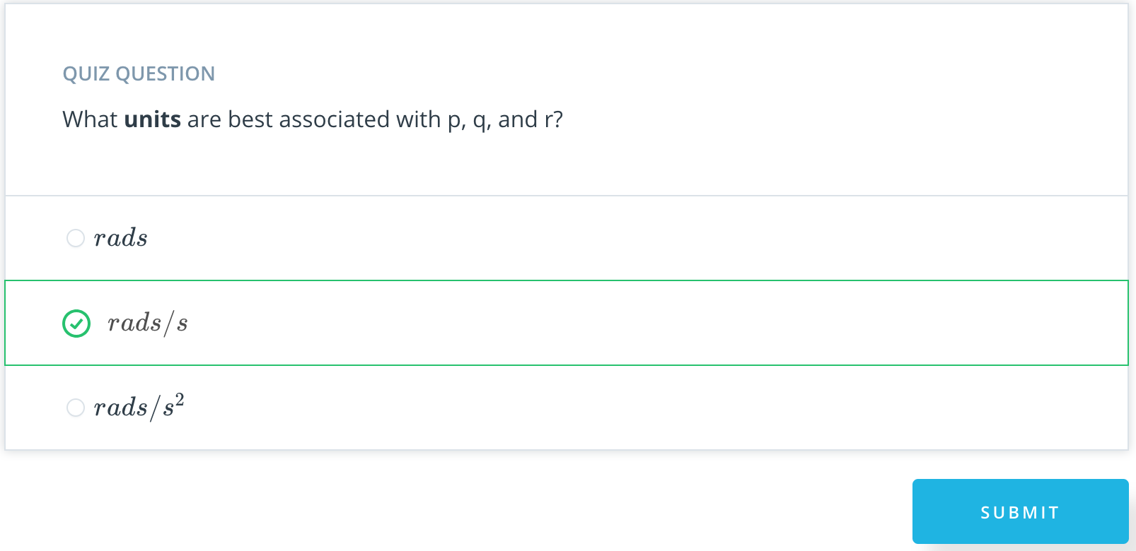

[6. Notebook Walkthrough](https://classroom.udacity.com/nanodegrees/nd787/parts/3619d672-ce5b-4a29-8a15-172cb667b5bb/modules/b78ec22c-5afe-444b-8719-b390bd2b2988/lessons/2263120a-a3c4-4b5a-9a96-ac3e1dbae179/concepts/38ac72ca-1eb0-4293-9d29-758eb2725323)

<https://www.youtube.com/watch?time_continue=19&v=xnggxr3Pz38>

[7. 3D Drone Part 1 Exercise](https://classroom.udacity.com/nanodegrees/nd787/parts/3619d672-ce5b-4a29-8a15-172cb667b5bb/modules/b78ec22c-5afe-444b-8719-b390bd2b2988/lessons/2263120a-a3c4-4b5a-9a96-ac3e1dbae179/concepts/bc02deb2-aae2-41a5-b517-b2fe846ac1cf)

Lesson 4 - 3D Drone-Full-Notebook.ipynb

[8. Tracking Rotations in 3D](https://classroom.udacity.com/nanodegrees/nd787/parts/3619d672-ce5b-4a29-8a15-172cb667b5bb/modules/b78ec22c-5afe-444b-8719-b390bd2b2988/lessons/2263120a-a3c4-4b5a-9a96-ac3e1dbae179/concepts/def1894d-ac59-42c9-a359-081274569487)

<https://www.youtube.com/watch?time_continue=2&v=2u6-2Ts7UUk>

[9. Euler's Equations in a Rotating Frame](https://classroom.udacity.com/nanodegrees/nd787/parts/3619d672-ce5b-4a29-8a15-172cb667b5bb/modules/b78ec22c-5afe-444b-8719-b390bd2b2988/lessons/2263120a-a3c4-4b5a-9a96-ac3e1dbae179/concepts/95131517-0fc7-40de-95e7-3db137cea9d5)

<https://www.youtube.com/watch?v=7VyzQGlax_0>

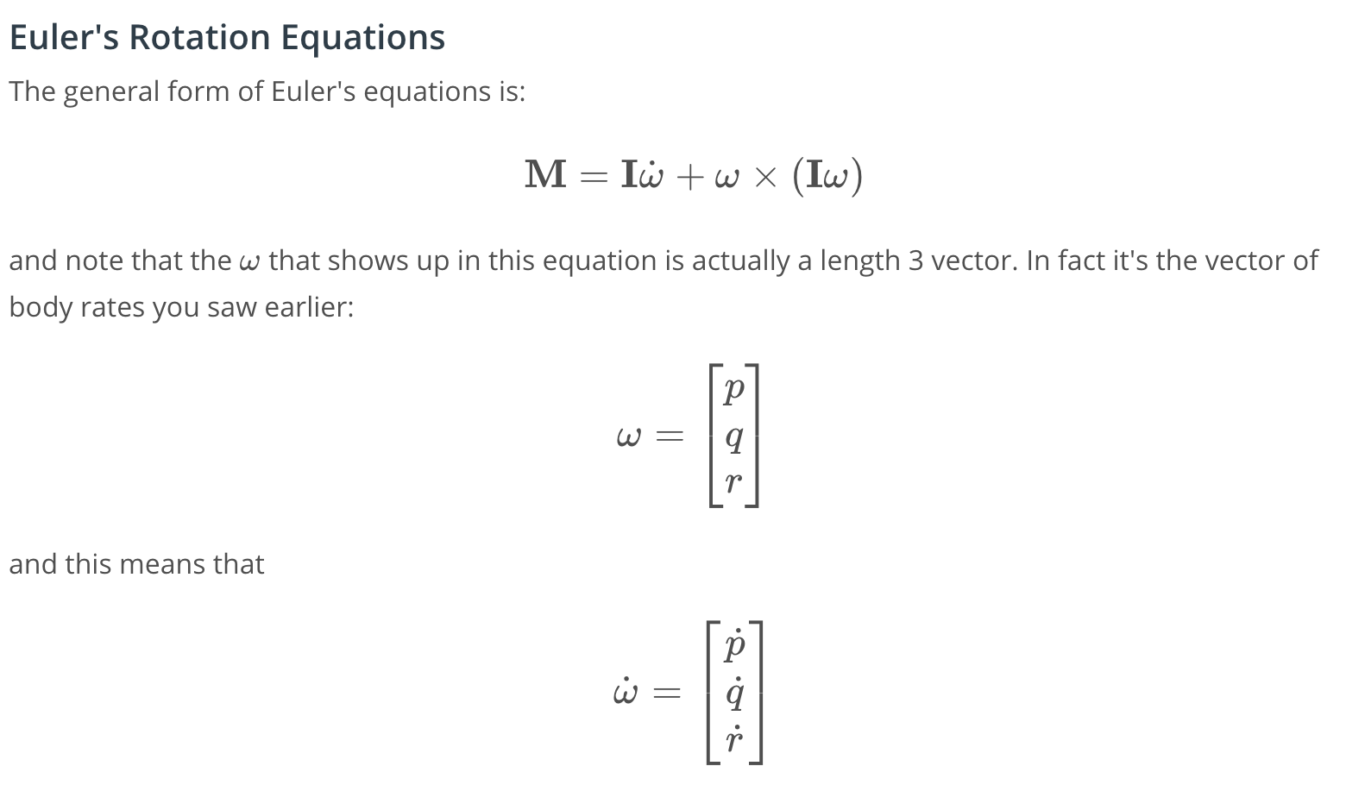

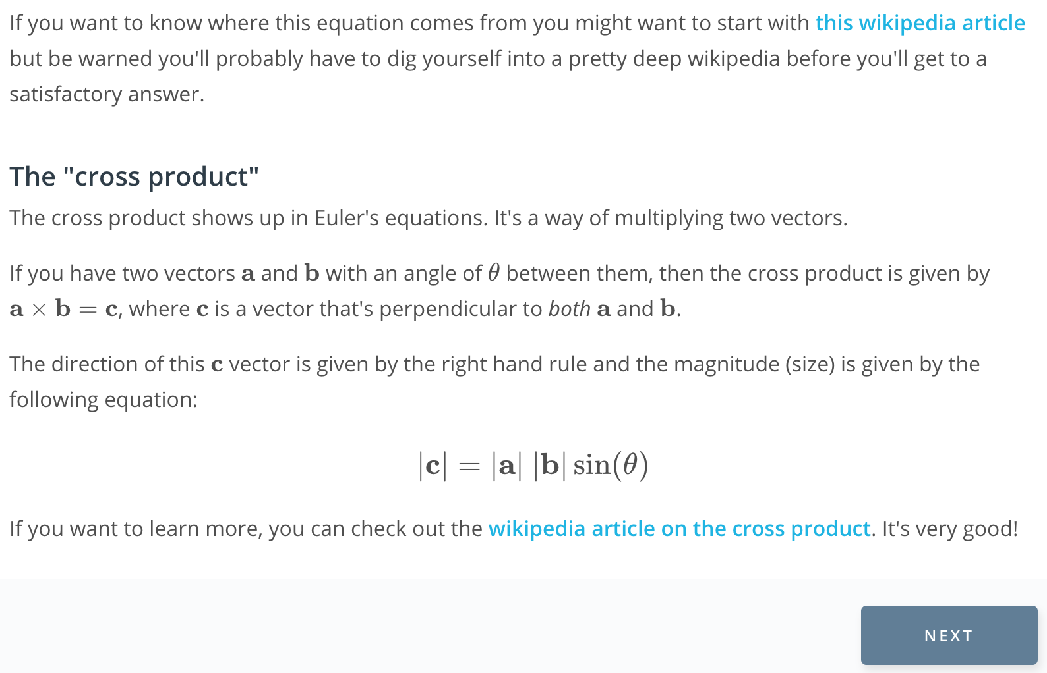

[this wikipedia article](https://en.wikipedia.org/wiki/Euler%27s_equations_(rigid_body_dynamics%29)

[wikipedia article on the cross product](https://en.wikipedia.org/wiki/Cross_product).

[10. 3D Drone Part 2 Exercise](https://classroom.udacity.com/nanodegrees/nd787/parts/3619d672-ce5b-4a29-8a15-172cb667b5bb/modules/b78ec22c-5afe-444b-8719-b390bd2b2988/lessons/2263120a-a3c4-4b5a-9a96-ac3e1dbae179/concepts/6160603f-1be3-44e9-acac-c79bfcf00851)

[11. Integrating PQR Into the World Frame](https://classroom.udacity.com/nanodegrees/nd787/parts/3619d672-ce5b-4a29-8a15-172cb667b5bb/modules/b78ec22c-5afe-444b-8719-b390bd2b2988/lessons/2263120a-a3c4-4b5a-9a96-ac3e1dbae179/concepts/3e891c40-e3e7-4147-8f6a-d503c55611bc)

<https://www.youtube.com/watch?v=taxXqgdHk0w>

## **Additional Resources**

* [Representing Attitude: Euler Angles, Unit Quaternions, and Rotation Vectors](https://www.astro.rug.nl/software/kapteyn/_downloads/attitude.pdf) is a very thorough exploration of attitude representations. Equation 79 in that paper corresponds to the equation shown in the video above.

[12. 3D Drone Part 3 Exercise](https://classroom.udacity.com/nanodegrees/nd787/parts/3619d672-ce5b-4a29-8a15-172cb667b5bb/modules/b78ec22c-5afe-444b-8719-b390bd2b2988/lessons/2263120a-a3c4-4b5a-9a96-ac3e1dbae179/concepts/8b388bf7-96dd-41b6-a11f-b134224a6ac1)

[13. Summary of 3D Dynamics](https://classroom.udacity.com/nanodegrees/nd787/parts/3619d672-ce5b-4a29-8a15-172cb667b5bb/modules/b78ec22c-5afe-444b-8719-b390bd2b2988/lessons/2263120a-a3c4-4b5a-9a96-ac3e1dbae179/concepts/d24169c6-1f5e-4915-8d2e-371b1b6ea4b4)

<https://www.youtube.com/watch?v=84UzlNJKWkw>

## **Before you continue...**

First skim through sections I and II and then carefully read section III of [Feasibility of Motion Primitives for Choreography](http://flyingmachinearena.org/wp-content/publications/2011/schoellig_feasibility_of_motion_primitives.pdf). This third section is called "Quadrocopter Dynamics and Constraints", and it provides a good summary of some of the concepts we've been discussing. You may find some of the later sections interesting as well.

Note that this paper uses slightly different notation than what we've been using in some parts. Most notably, where we've represented the Euler Angles with \phi, \theta, \psi*ϕ*,*θ*,*ψ* this paper uses \alpha, \beta, \gamma*α*,*β*,*γ*.

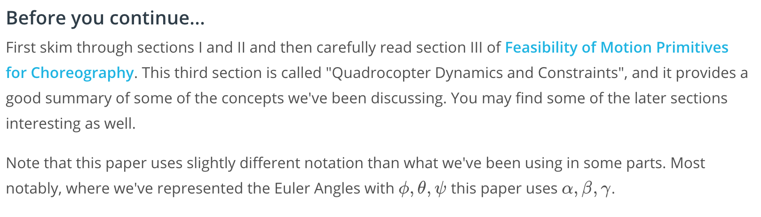

[14. "Control Knobs" for a 3D Quadrotor](https://classroom.udacity.com/nanodegrees/nd787/parts/3619d672-ce5b-4a29-8a15-172cb667b5bb/modules/b78ec22c-5afe-444b-8719-b390bd2b2988/lessons/2263120a-a3c4-4b5a-9a96-ac3e1dbae179/concepts/9ee6e206-481c-4711-9d5f-18889dd3ec15)

<https://www.youtube.com/watch?time_continue=1&v=WJ5lRmX7_To>

[15. 3D Control Architecture](https://classroom.udacity.com/nanodegrees/nd787/parts/3619d672-ce5b-4a29-8a15-172cb667b5bb/modules/b78ec22c-5afe-444b-8719-b390bd2b2988/lessons/2263120a-a3c4-4b5a-9a96-ac3e1dbae179/concepts/04cab5cc-e297-4a98-8c16-6c8107bec2ad)

<https://www.youtube.com/watch?time_continue=2&v=CsN5-lHcxyM>

[16. First vs Second Order Systems](https://classroom.udacity.com/nanodegrees/nd787/parts/3619d672-ce5b-4a29-8a15-172cb667b5bb/modules/b78ec22c-5afe-444b-8719-b390bd2b2988/lessons/2263120a-a3c4-4b5a-9a96-ac3e1dbae179/concepts/98515101-c3bb-4fdf-8bce-1a9f5ab48e74)

<https://www.youtube.com/watch?v=1Ilt2w17LMU>



## **Before you continue...**

Please read sections 3 and 4 of this paper: [Feed-Forward Parameter Identification](http://www.dynsyslab.org/wp-content/papercite-data/pdf/schoellig-acc12.pdf). As you read through, pay attention to equations (2), (4), (5), and (6).

[17. Understanding Attitude Control Equations](https://classroom.udacity.com/nanodegrees/nd787/parts/3619d672-ce5b-4a29-8a15-172cb667b5bb/modules/b78ec22c-5afe-444b-8719-b390bd2b2988/lessons/2263120a-a3c4-4b5a-9a96-ac3e1dbae179/concepts/18bb7626-f531-496f-8c60-9ecf01f0e583)

<https://www.youtube.com/watch?time_continue=2&v=1g_uyhDgoiQ>

[18. 3D Drone Part 4 Exercise](https://classroom.udacity.com/nanodegrees/nd787/parts/3619d672-ce5b-4a29-8a15-172cb667b5bb/modules/b78ec22c-5afe-444b-8719-b390bd2b2988/lessons/2263120a-a3c4-4b5a-9a96-ac3e1dbae179/concepts/06f71789-746f-4653-9d1c-9cadeafc5a4f)

[19. Controller Design](https://classroom.udacity.com/nanodegrees/nd787/parts/3619d672-ce5b-4a29-8a15-172cb667b5bb/modules/b78ec22c-5afe-444b-8719-b390bd2b2988/lessons/2263120a-a3c4-4b5a-9a96-ac3e1dbae179/concepts/43d9e2fe-7ce6-441d-a1fd-2a4a343186f2)

<https://www.youtube.com/watch?v=9WtAmL_aa3c>

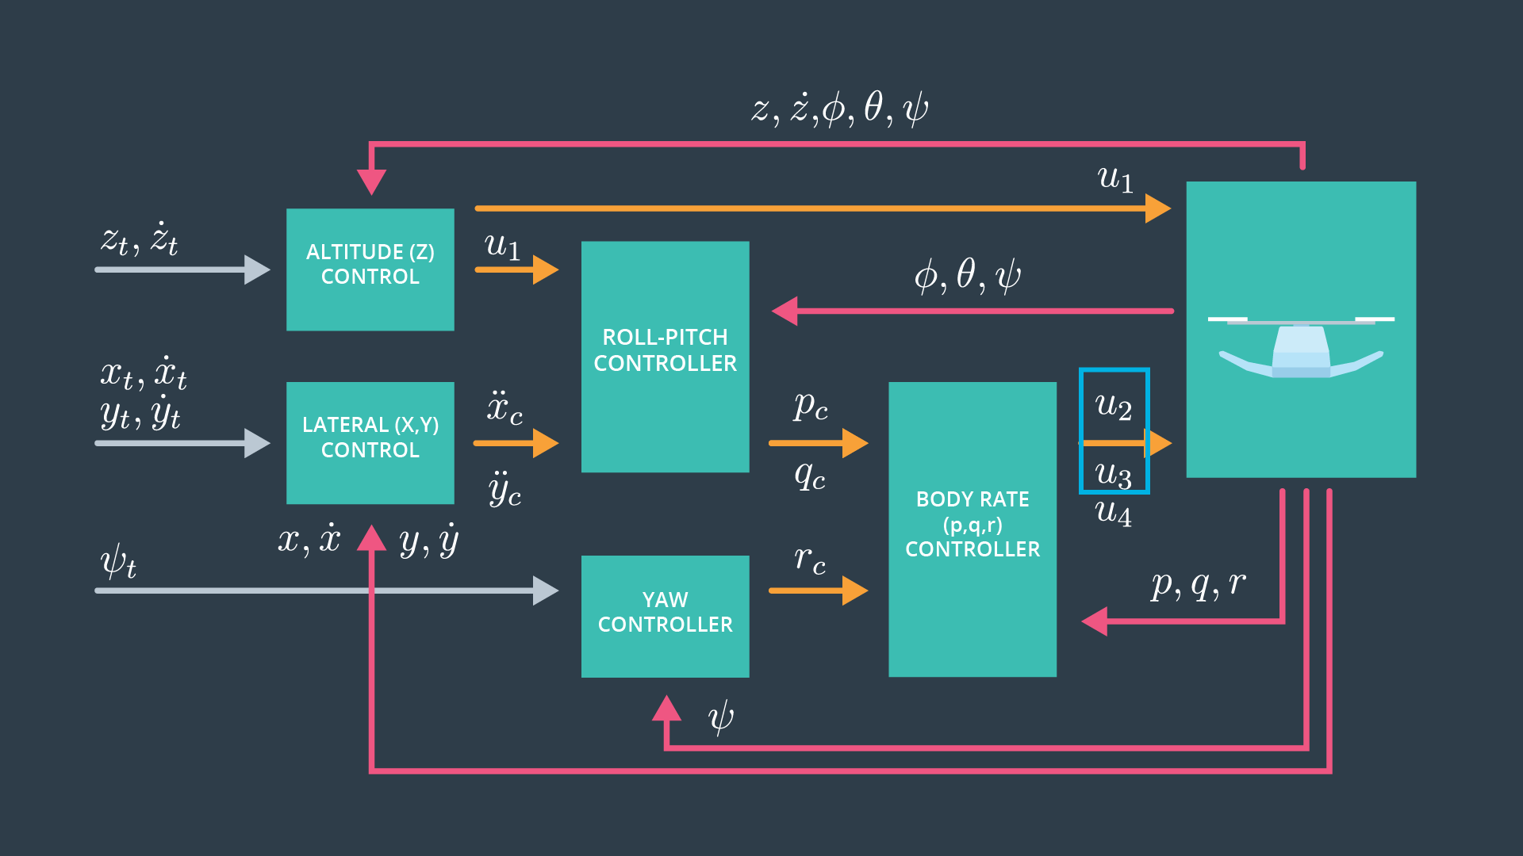

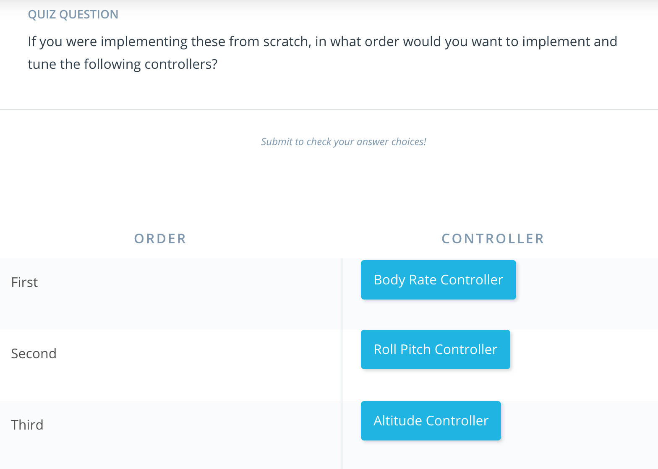



[20. Controller Design 2](https://classroom.udacity.com/nanodegrees/nd787/parts/3619d672-ce5b-4a29-8a15-172cb667b5bb/modules/b78ec22c-5afe-444b-8719-b390bd2b2988/lessons/2263120a-a3c4-4b5a-9a96-ac3e1dbae179/concepts/2521e8ff-f71f-4797-b9d3-769c42afa8bc)

<https://www.youtube.com/watch?time_continue=5&v=nKw5PD19cZo>

[21. 3D Drone Part 5 Exercise](https://classroom.udacity.com/nanodegrees/nd787/parts/3619d672-ce5b-4a29-8a15-172cb667b5bb/modules/b78ec22c-5afe-444b-8719-b390bd2b2988/lessons/2263120a-a3c4-4b5a-9a96-ac3e1dbae179/concepts/47b0380b-3d5a-426b-8409-45f947c8f343)

Lesson 4 - 3D Drone-Full-Notebook.ipynb

[22. Practical Considerations](https://classroom.udacity.com/nanodegrees/nd787/parts/3619d672-ce5b-4a29-8a15-172cb667b5bb/modules/b78ec22c-5afe-444b-8719-b390bd2b2988/lessons/2263120a-a3c4-4b5a-9a96-ac3e1dbae179/concepts/f225f6b3-d64b-4507-86e7-d4b3090a10f5)

<https://www.youtube.com/watch?time_continue=1&v=jPKfF11h4mE>

[23. From Path Planning to Control](https://classroom.udacity.com/nanodegrees/nd787/parts/3619d672-ce5b-4a29-8a15-172cb667b5bb/modules/b78ec22c-5afe-444b-8719-b390bd2b2988/lessons/2263120a-a3c4-4b5a-9a96-ac3e1dbae179/concepts/65365a7b-8b92-42b0-b4ec-cc28b1163e3f)

<https://www.youtube.com/watch?time_continue=3&v=otFd1oWj_Qs>

[24. Trajectory Generation Exercise](https://classroom.udacity.com/nanodegrees/nd787/parts/3619d672-ce5b-4a29-8a15-172cb667b5bb/modules/b78ec22c-5afe-444b-8719-b390bd2b2988/lessons/2263120a-a3c4-4b5a-9a96-ac3e1dbae179/concepts/b4f15afb-58ec-40f1-9d18-c4b865d7e75b)

[Trajectory generation linear segments 1 and 3 D .ipynb](https://view2d279359.udacity-student-workspaces.com/notebooks/Trajectory%20generation%20linear%20segments%201%20and%203%20D%20.ipynb)

[25. Polynomial Segmentation Exercise](https://classroom.udacity.com/nanodegrees/nd787/parts/3619d672-ce5b-4a29-8a15-172cb667b5bb/modules/b78ec22c-5afe-444b-8719-b390bd2b2988/lessons/2263120a-a3c4-4b5a-9a96-ac3e1dbae179/concepts/bf52c72d-6093-428d-aef8-33a5c7ec83b7)

[Trajectory generation polynomial.ipynb](https://view198c3700.udacity-student-workspaces.com/notebooks/Trajectory%20generation%20polynomial.ipynb)

[26. Conclusion](https://classroom.udacity.com/nanodegrees/nd787/parts/3619d672-ce5b-4a29-8a15-172cb667b5bb/modules/b78ec22c-5afe-444b-8719-b390bd2b2988/lessons/2263120a-a3c4-4b5a-9a96-ac3e1dbae179/concepts/e388bac9-6e55-45d8-8fa4-ef7ab2e236b4)

<https://www.youtube.com/watch?time_continue=3&v=BSTb2Uxm3go>